Clustering over the BeNeLux – Modelling of dependent windstorms

Every winter the Netherlands is hit by several storms, in some cases these storms have peak gusts over 100 km per hour. Those extreme winter storms can cause big losses for insurers and are the most damaging insured natural catastrophes in the Netherlands. Therefore this risk is often reinsured and this catastrophe risk is important for both insurers and reinsurers. When a windstorm arrives in the European mainland, there appears to be an increased chance of another storm arriving. This weather feature has recently gained attention of catastrophe modellers and is important in the determination of capital requirements. When storms arrive in clusters these might be depend events which require more risk capital. This article describes the modelling of catastrophe risk and depend windstorms, the definition of clustering and the processes underlying this risk.

*Catastrophe models*

First, the modelling of catastrophe will be briefly explained. Catastrophe risk is often calculated for (re)insurers by so called vendors. They design the models based on weather and exposure data and sell the results of these calculations. Catastrophe models consist of several modules that perform the calculations. First an hazard module generates the storms and their intensity combined with an exposure module that gives all the relevant characteristics of the insured values. Then the vulnerability module calculates the resulting damage. Finally the financial module exists to calculate the financial consequences of a catastrophe. This is a possible place to incorporate effects of clustering through post loss amplification. Since vendors do not disclose their methods regarding the incorporation of clustering the remainder of this article focuses on the modelling of clustering in storm arrival which is part of the hazard module of catastrophe models.

The capital requirements for insurers and reinsurers can be calculated according to the standard model specifications of the European Insurance Authority. These specifications explicitly assume two consecutive storms to be independent. However, for the correct modelling, in for example an internal model, the effect of clustering should be incorporated. This is, besides the limited information on clustering in vendor models, an important reason to investigate clustering.

*Storm arrival*

Based on Dutch and Belgian weather data, a model for the arrival rate of severe storms is constructed. To model the dependence in the arrival of storms per winter, a list of storms is identified from wind gusts data of the Belgian and Dutch Royal weather institutes. The storms are identified using the method that is often used in other studies1. The two percent heaviest gusts per weather station are normalised, cubed and summed to get arrival dates of storms. In contrary to the usual assumption of independency the weather data showed clearly overdispersion. Besides the homogeneous Poisson process other theoretical distributions with a parameters for dispersion are fitted on the observed distribution of storms per winter. Of this distributions the Negative Binomial distribution shows the best fit. In addition, the excess of winters with zero heavy storms is modelled with zero-inflated and zero-adjusted models which also improve the simple Poisson model.

*Modelling clusters*

An alternative model that comes closer to the actual process underlying the cluster development is the Poisson-Binomial model. In this model the number of clusters per winter and the size of the clusters are estimated separately. Storms arriving together within seven, fourteen and thirty day windows are identified as clusters.

|  |  |  |  |
| --- | --- | --- | --- |
|  | Window size | | |
| Cluster size | 7 days | 14 days | 30 days |
| 1 | 69 | 53 | 17 |
| 2 | 23 | 21 | 22 |
| 3 | 1 | 5 | 9 |
| 4 |  | 2 | 6 |
| 5 |  |  |  |
| 6 |  |  | 1 |

*Storms per cluster for different arriving periods.*

The number of clusters is estimated with a homogeneous Poisson process after which the cluster size is estimated with a Binomial distribution. When defining clusters as storms arriving within seven or fourteen days the Poisson-Binomial distribution fits well. However, when increasing the time frame to thirty days the predictive power diminishes. This makes sense since less information about the interarrival times of storms is used. Estimation of this model is a step in the definition of clustering

*Pricing*

Based on the estimated distributions the effect of clustering on insurance premiums can be calculated2. This calculation relies on strong assumptions and should not be overvalued but gives an easily implemented method that shows the impact of clustering. Premiums are based on the occurrence exceedance probability – the distribution of the maximum loss in a given year. The premiums are based on the expect level of loss for one event. For multiple events (a cluster) the probability conditional on one at least one event should be taken. This probability depends on the parameters of the chosen distribution. The correction on the premiums can be up to eight percent.

*Post loss amplification*

An alternative to the statistical modelling of clusters is the possibility to incorporate clustering in the post loss amplification. This alternative approach overcomes problems that arise when one tries to combine the probabilities of losses in a statistically correct manner. Instead the losses of a first storm are exacerbated for the possibility of losses due to following storms.

*Clustering or coincidence?*

Obviously insurers are mostly interested in the number of storms that are actually arriving over the BeNeLux. Nevertheless it is important to understand the underlying processes of dependent development of storms when modelling the losses. The storms arriving within short time intervals do not necessarily have the same origin. To describe the clustered arrival, a distinction is made between secondary cyclogenesis, clustering due to large scale pressure variations, and storms that appear to arrive independently. To investigate nine periods of severe storms in the last twenty-five years and the different ways clusters develop, a simple JavaScript application is written. The visualisation is a powerful tool to compare the tracks and developments of storms in time. In two of those nine periods the first storm seems to initiate a second storm (secondary cyclogenesis). In four periods the storms develop separately but are steered to the European coast by large scale pressure patterns. In two periods the storms arrive together but develop and travel independently over the ocean. A period consisting of four big storms shows all of the three effects above and is a good example of the complexity of the processes underlying cluster development.

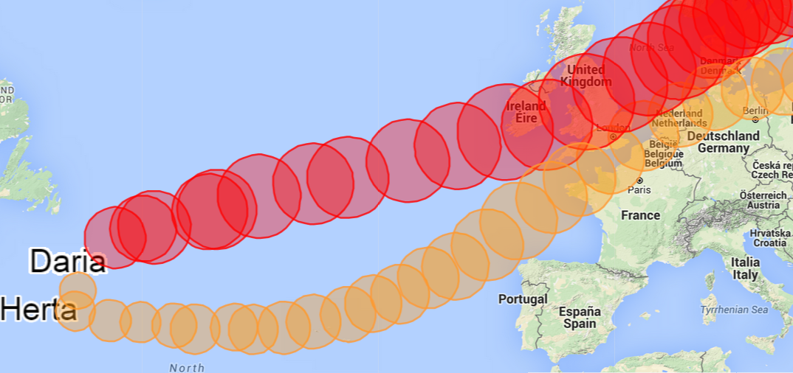

*The tracks of two storms arriving close to each other in 1990.*

Recent attention to clustering and the non-disclosure of the methods used in vendor models gave rise to the question how windstorm risk should be modelled. Weather data shows clear dependence in arrival and there are several suggestions to improve the current models. This risk of dependent events might be costly for insurers and reinsurers. The challenge will remain to model the storm arrivals as simply as possible while considering all factors that play a role and are relevant for insurers.

1. Klawa, M., & Ulbrich, U. (2003). A model for the estimation of storm losses and the identification of severe winter storms in Germany. Natural Hazards and Earth System Science, 3 , 725-732.
2. Application suggested in Cannelle, F. (2011). European winterstorms, an analysis of the clustering effect (Un-published master's thesis). Université Claude Bernard.